Alt attribute

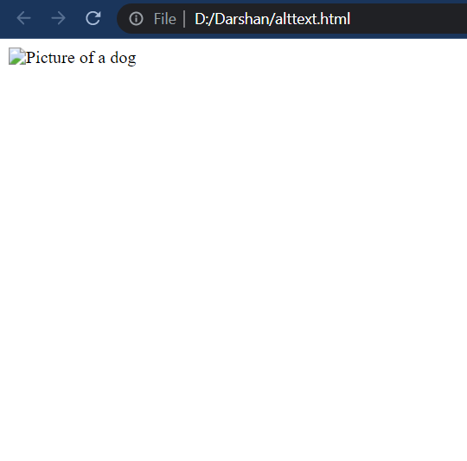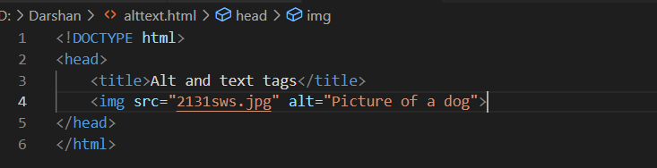Alt attribute is used to provide alternate information of an image when the image can not be displayed. Example : <img src=”picture.jpg” alt=”Photo of a dog”> . It can be useful when a picture fails to load.

Title attribute

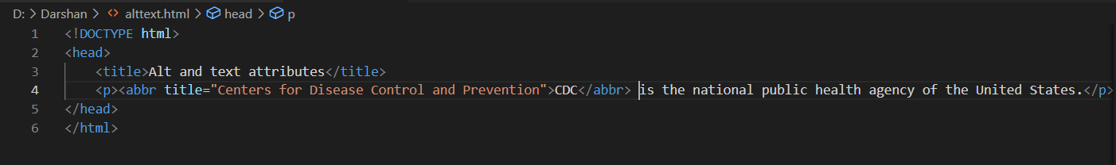Title attribute is used to provide additional information about an element which usually appears as a tooltip text when the cursor moves on the element. Example : <abbr title=”Happy Birthday”>HBD</abbr>

